*Florida International University*

*School of Computing and Information Sciences*

CIS 4911 - Senior Capstone Project

Software Engineering Focus

Feature Document

User Story # 1075

**Team Member:**

Daniel Lopez

**Product Owner(s)**:

Mohsen Taheri

**Mentor(s)**:

Mohsen Taheri

**Instructor**:

Mohsen Taheri

**User Story** Add Loading If Processes Are Loading In Background

**Description**

As a developer I would like users to see a loading if tasks are running in the background and are taking to long so that users know that background operations are loading.

**Acceptance Criteria**

1. Loading displayed only whilst loading.
2. Loading displayed disappears and regular message is displayed whilst loading is done.

**Use Case**

1. Participating Actors: User  
     
   Entry Condition: Long Background Process  
   Events Flow:
2. Hide elements that require data to be loaded.
3. Display animated loading gif to user.
4. Hide loading gif when processes done.
5. Show elements once data is loaded.

**Use Case Diagram**

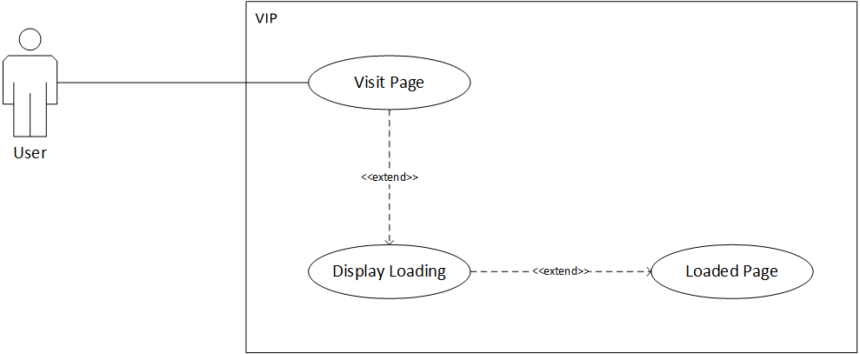

**Sequence Diagram**

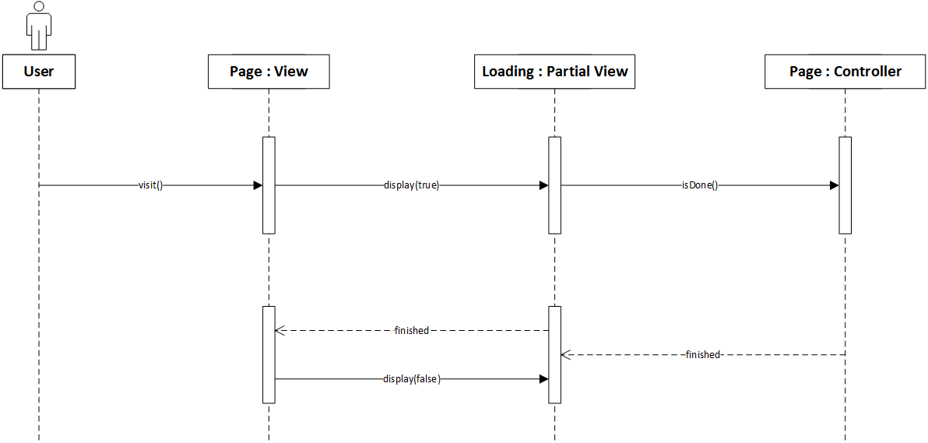

**Class Diagram**

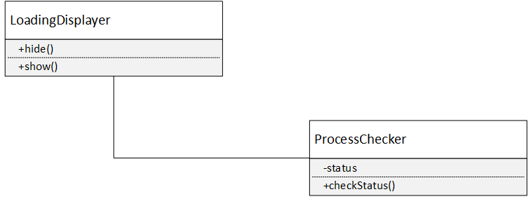

**Unit Test & Integration Test**

**Test Case 1 Sunny Day (PASS)**

* **Purpose**

To test that loading gif is shown when things are still loading.

* **Precondition**

Slow internet connection.

* **Input**

Enter to-do page.

* **Expected Result**

Loading gif shows whilst still loading and disappears when done. UI elements are shown with populated data once loading is complete.

* **Actual Result**

As Expected Result.

**Test Case 2 Rainy Day (FAIL)**

* **Purpose**

To test that loading gif is not shown when things are still loading.

* **Precondition**

Slow internet connection.

* **Input**

Enter to-do page.

* **Expected Result**

Loading gif shows whilst still loading and does not disappear when done. UI elements are shown with populated data once loading is complete.

* **Actual Result**

Loading gif shows whilst still loading and disappears when done. UI elements are shown with populated data once loading is complete.

**Visual User Guide**

